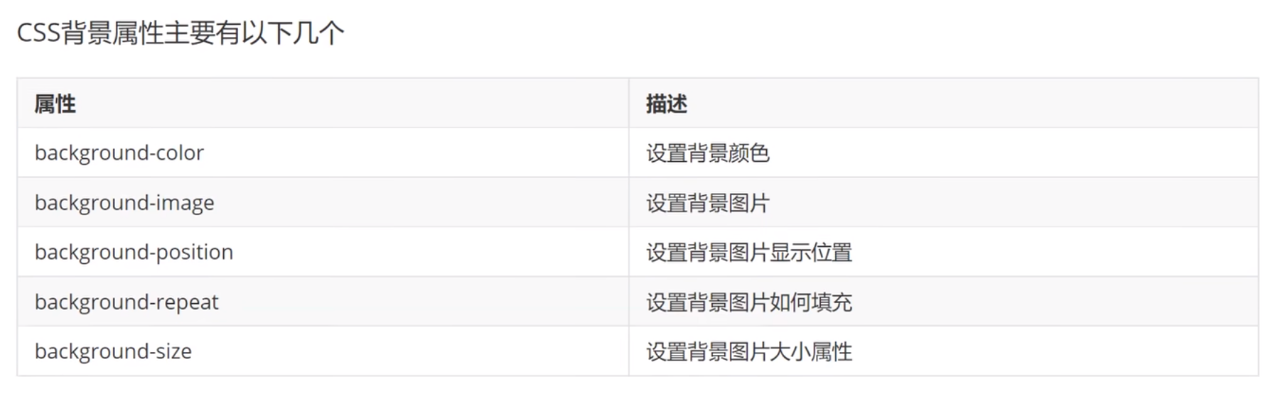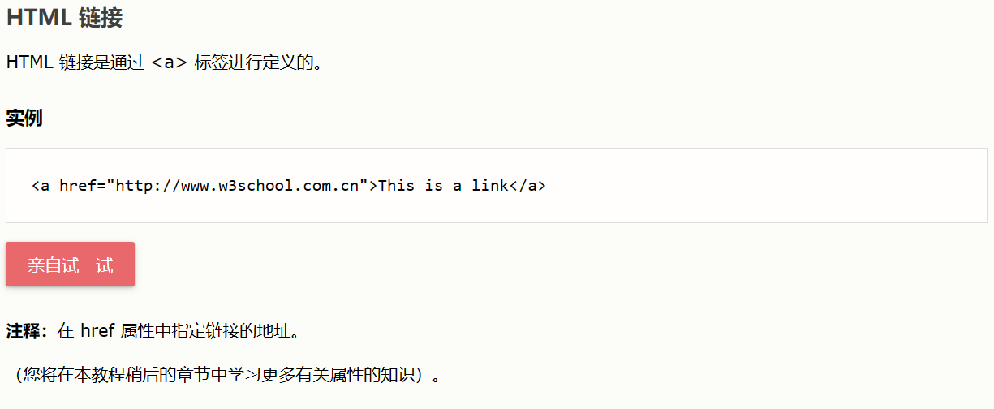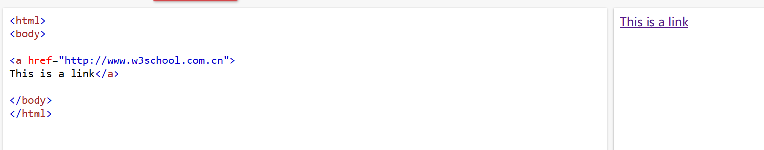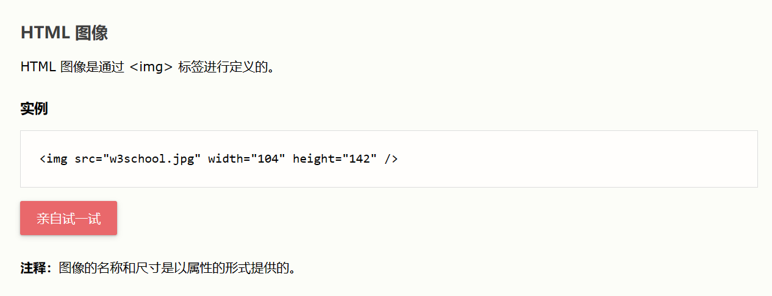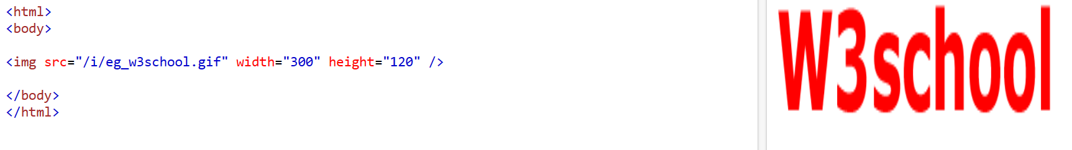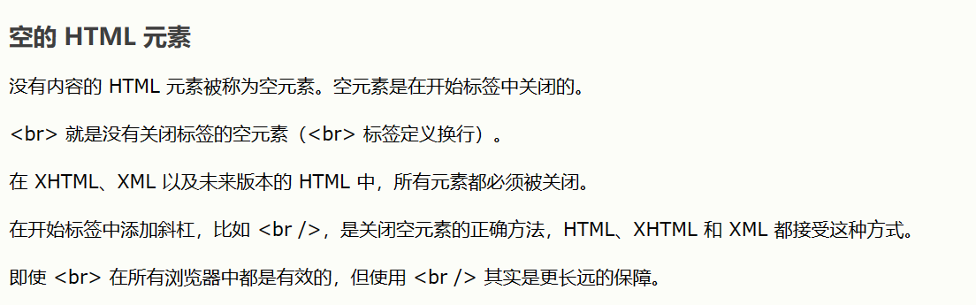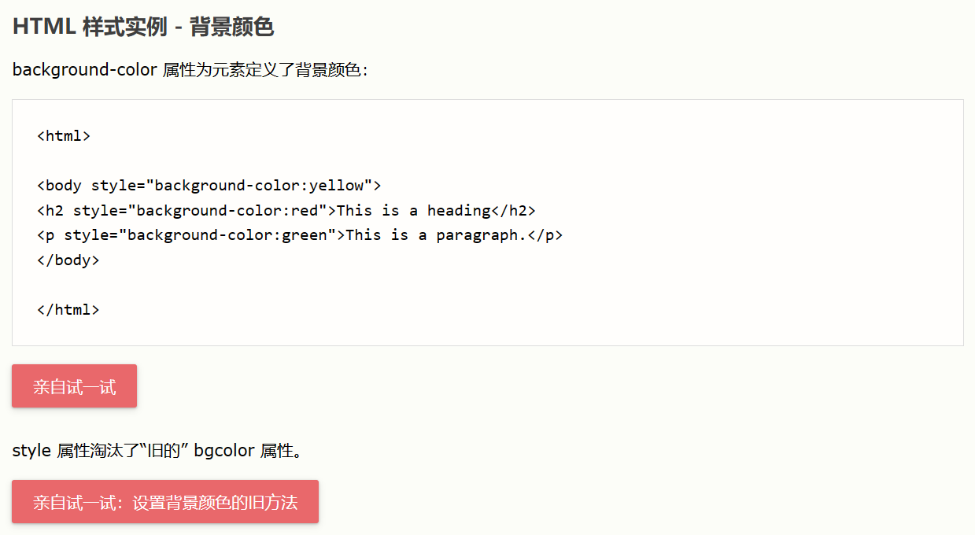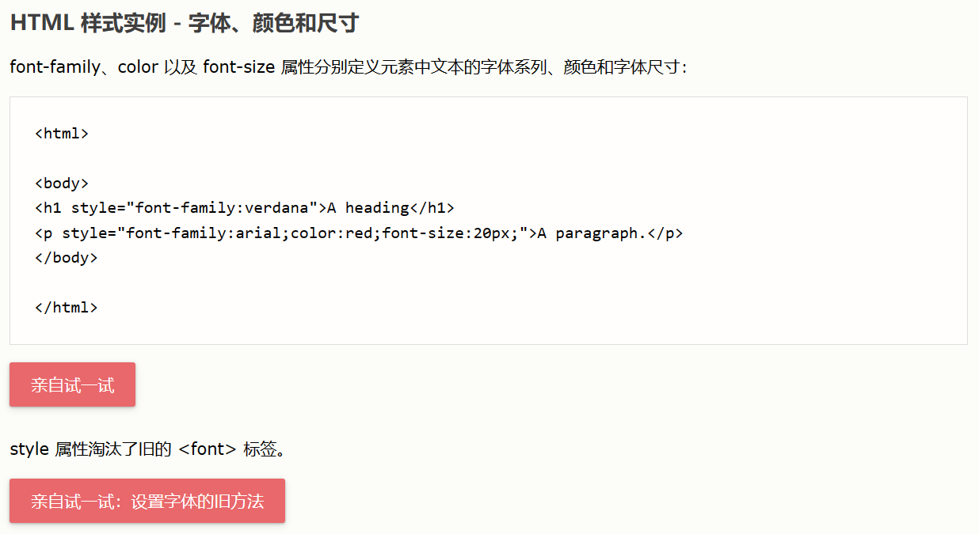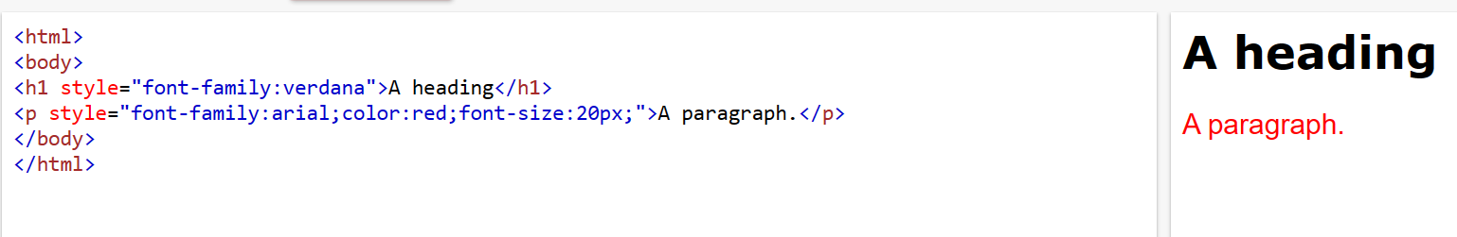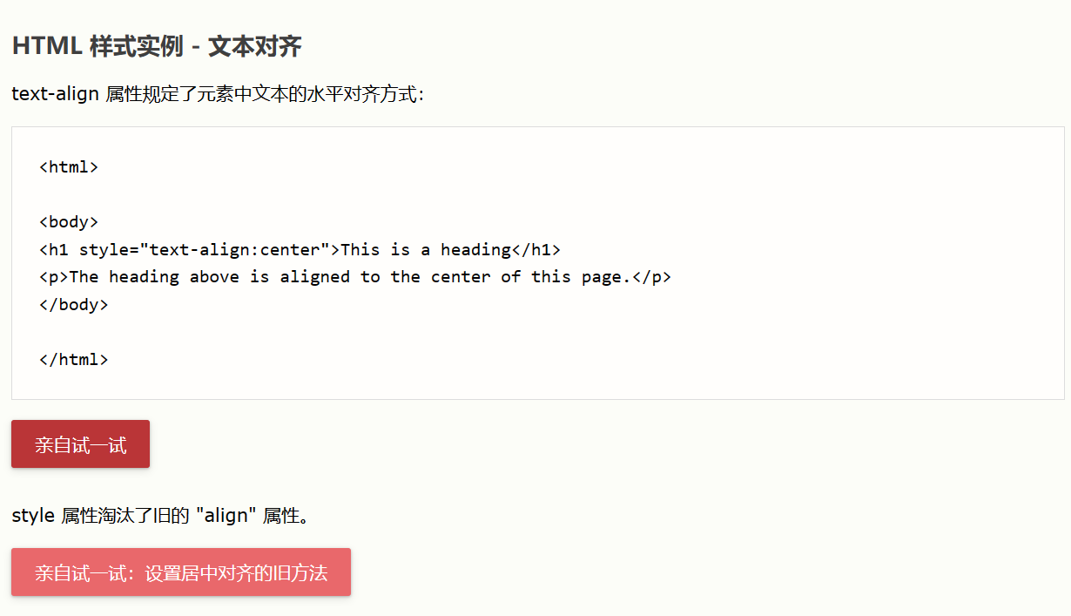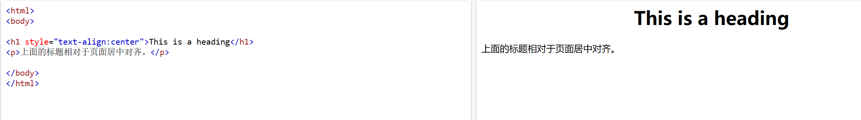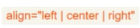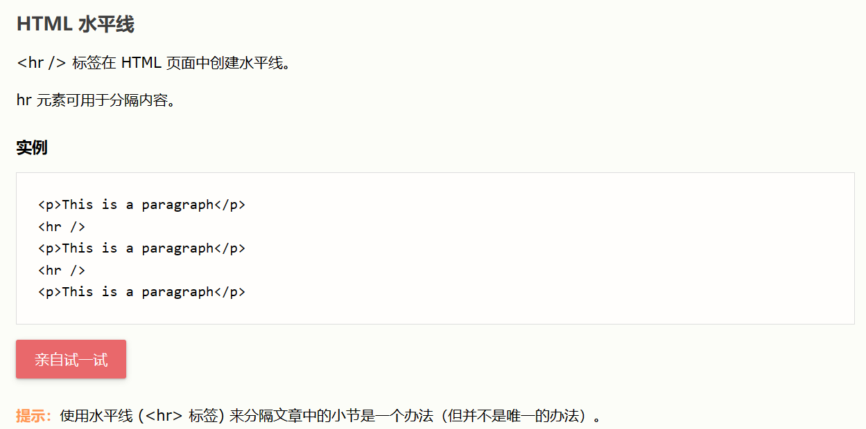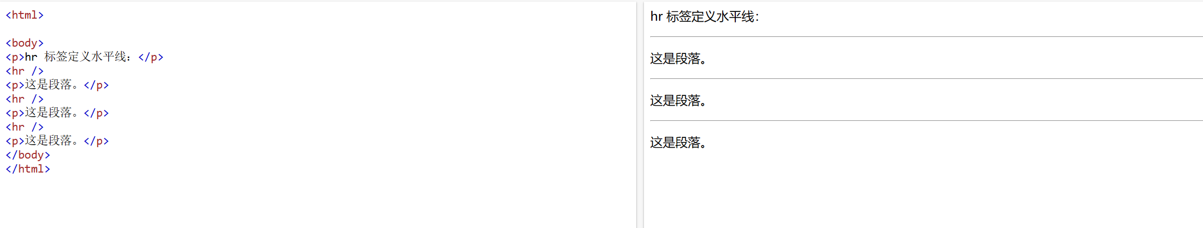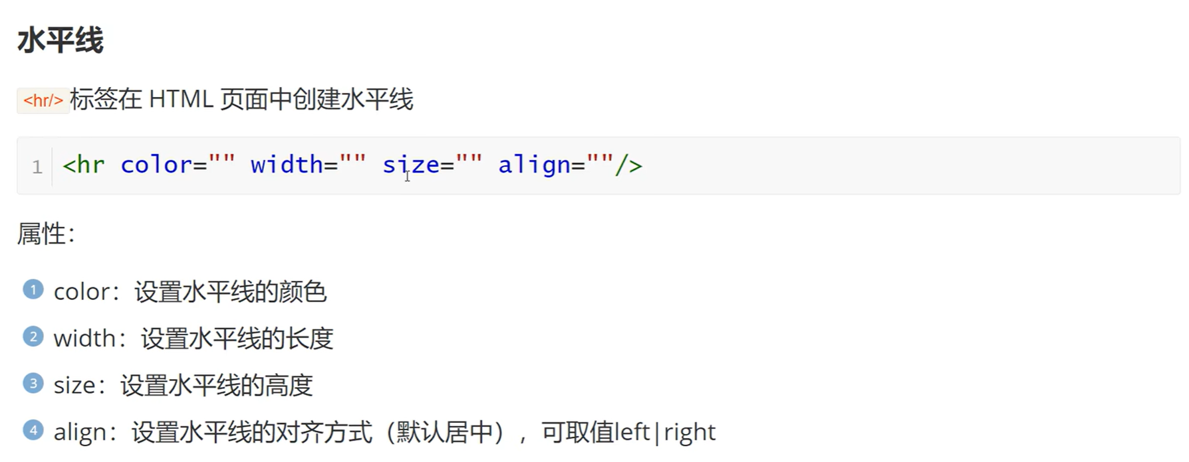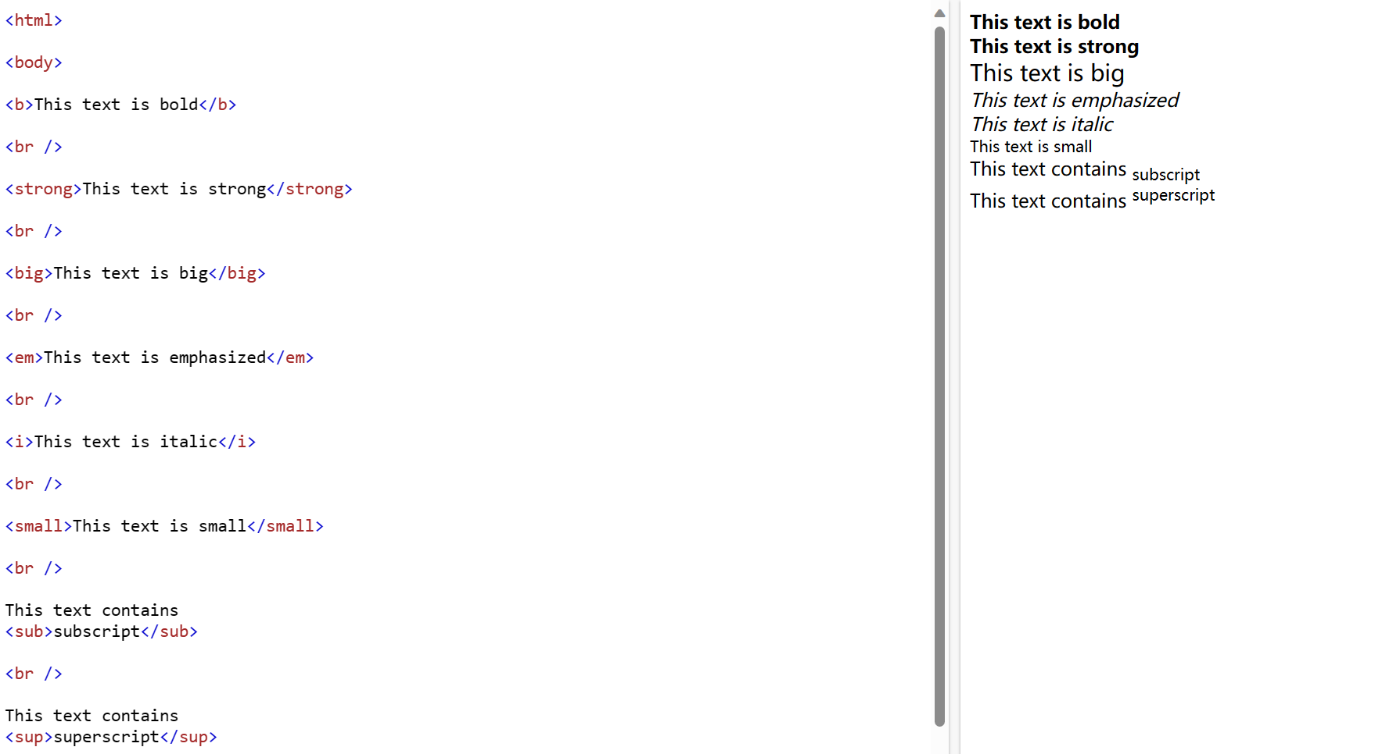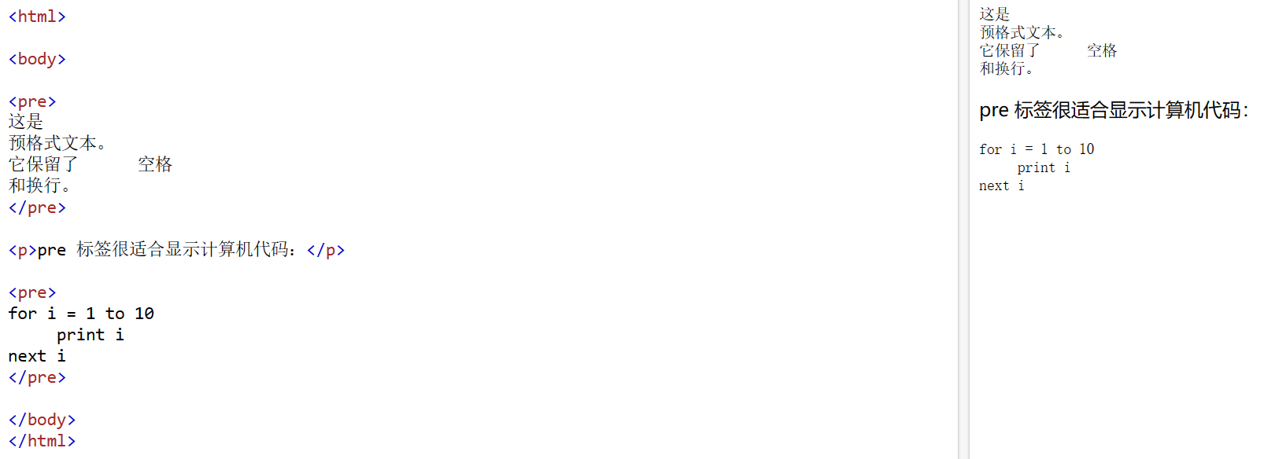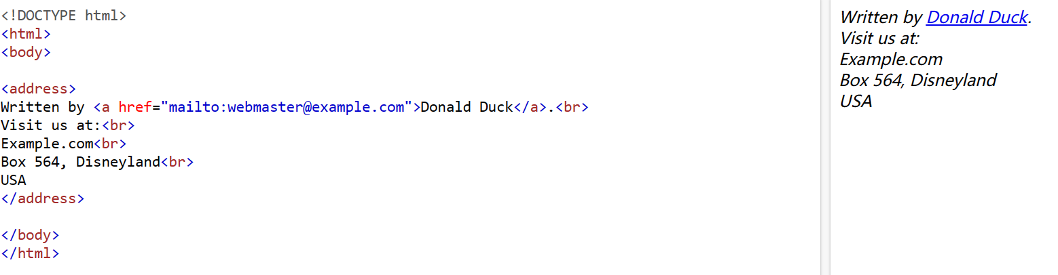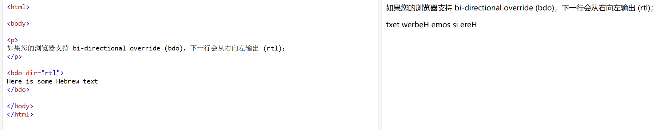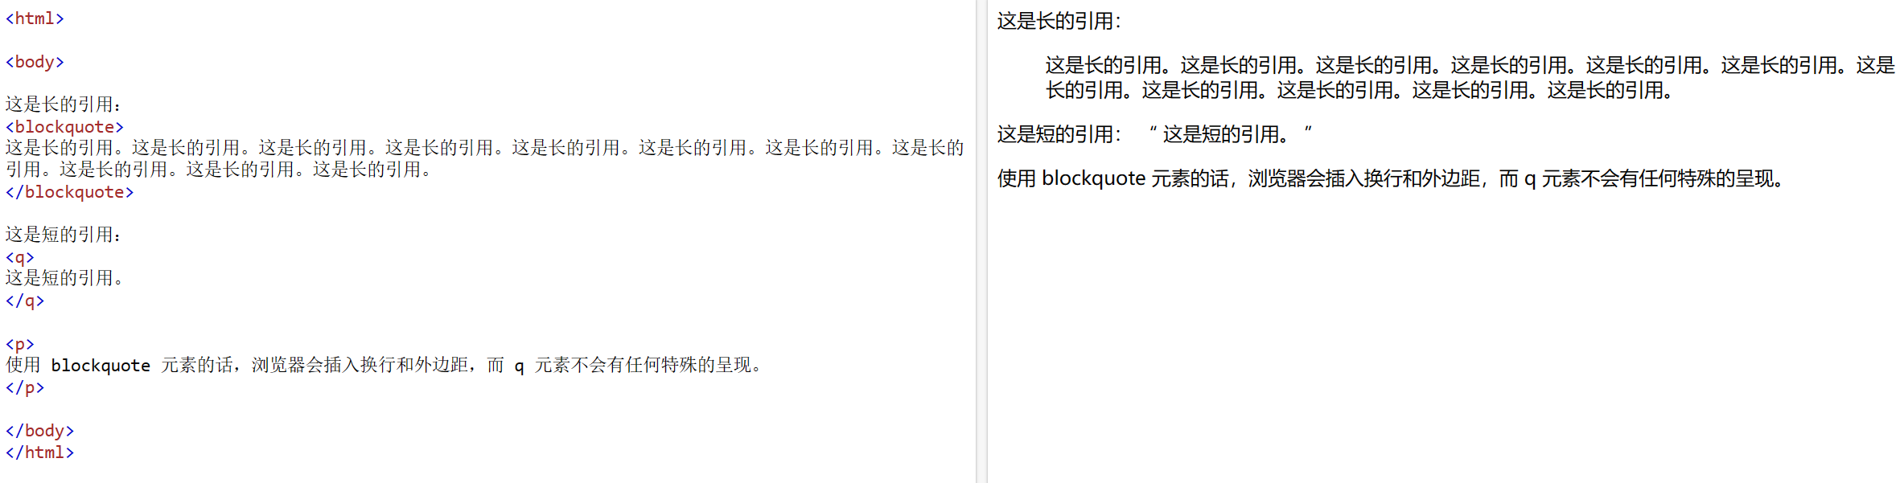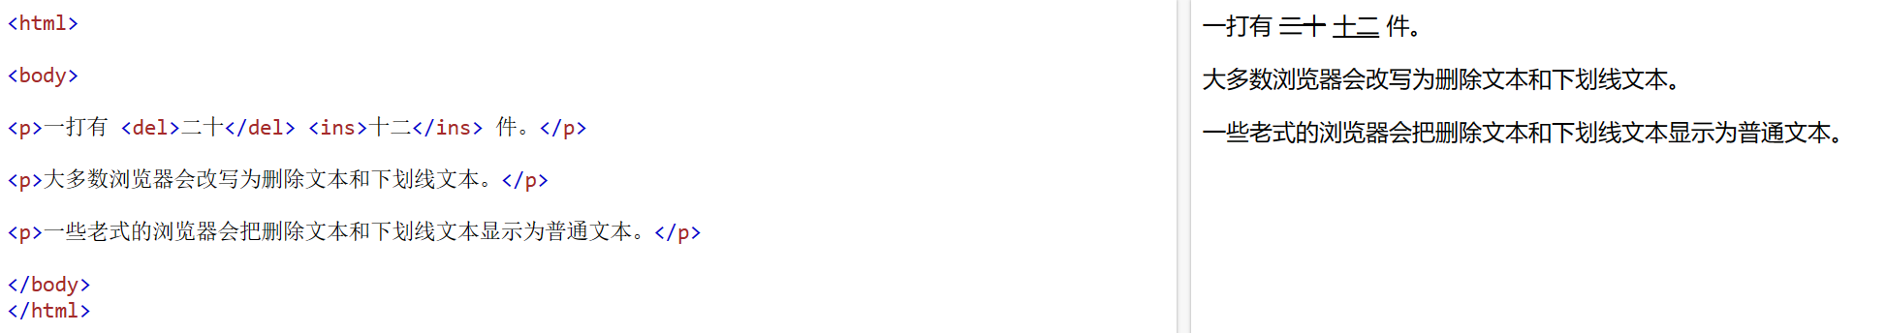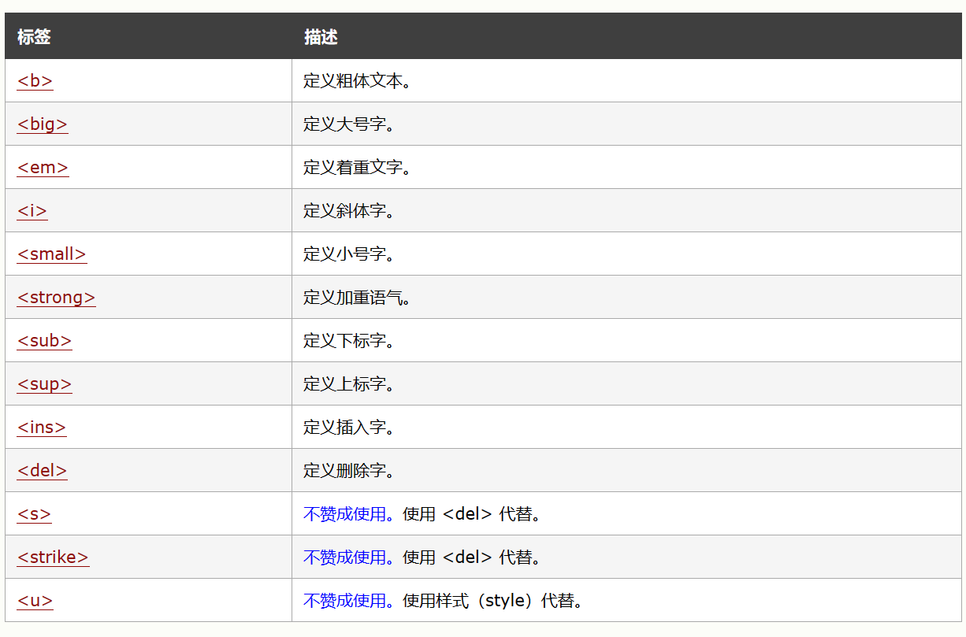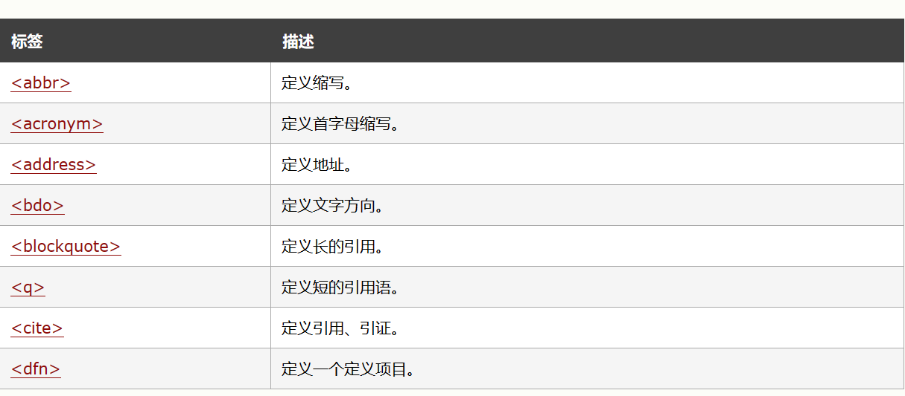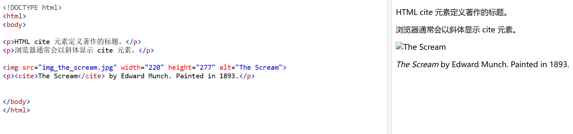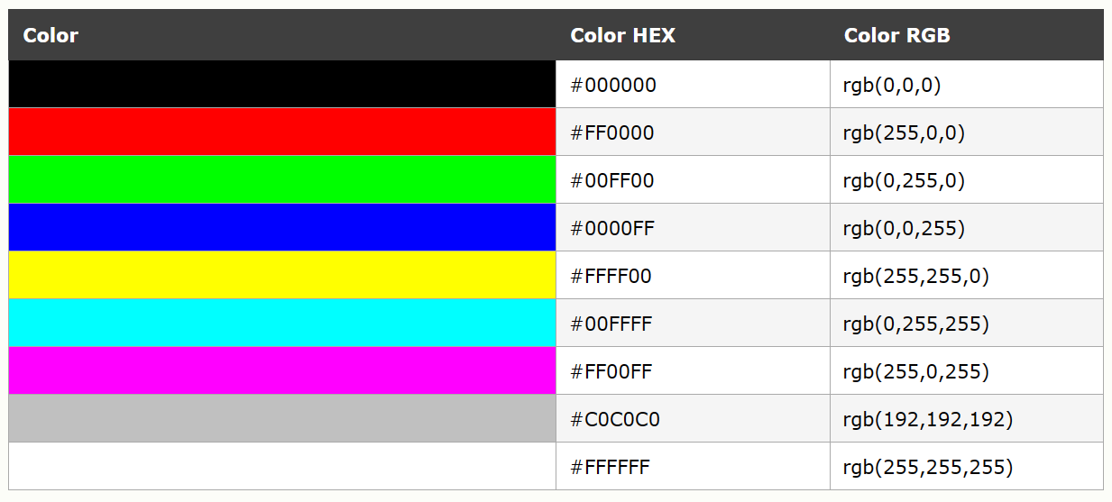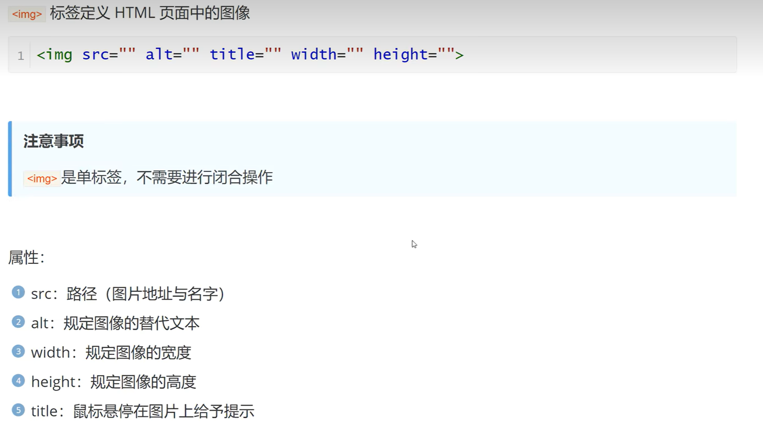

需要将图片保存到同一个文件夹里面，然后src“”填图片的名字即可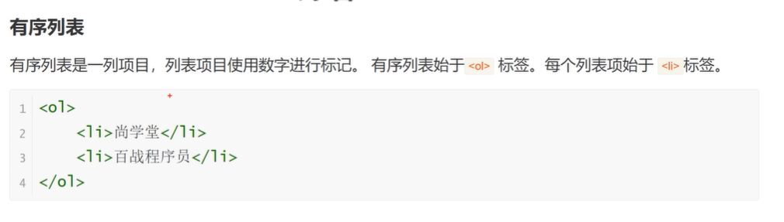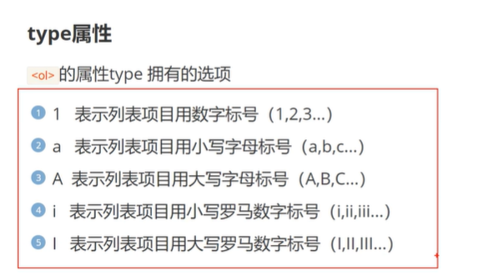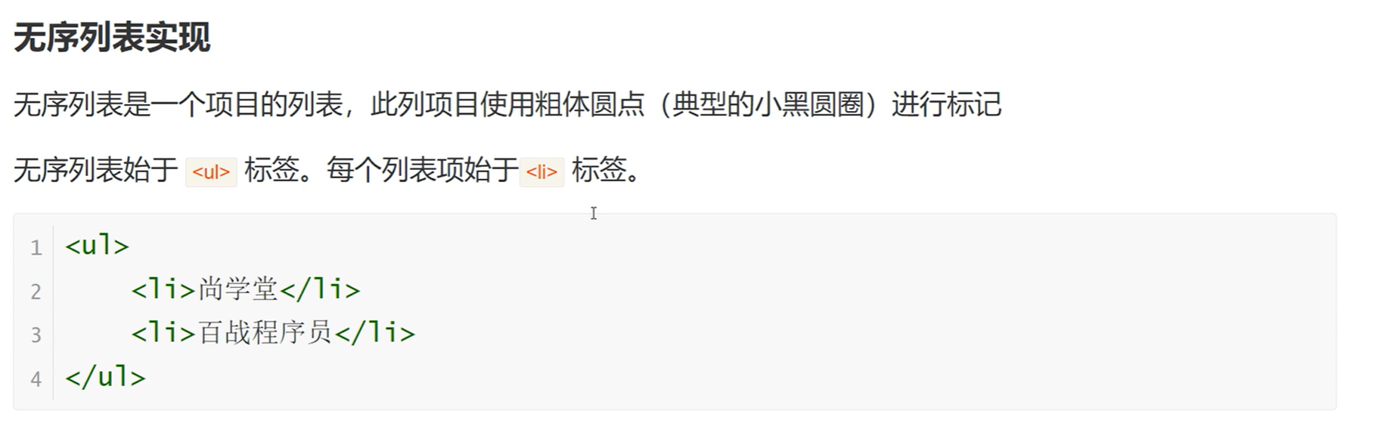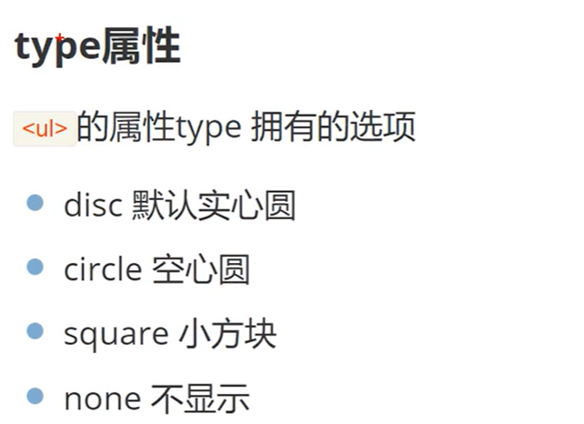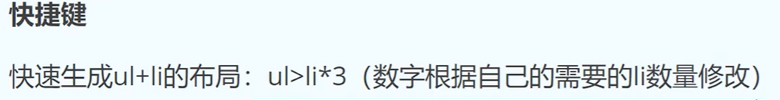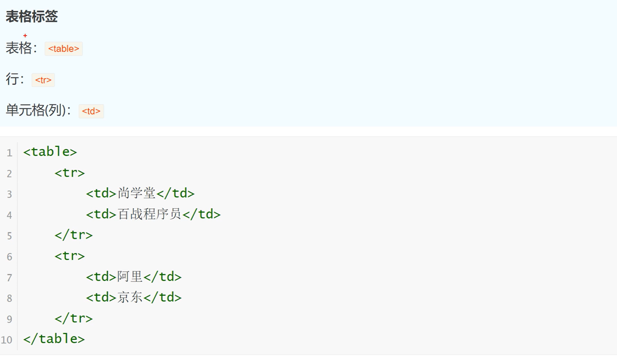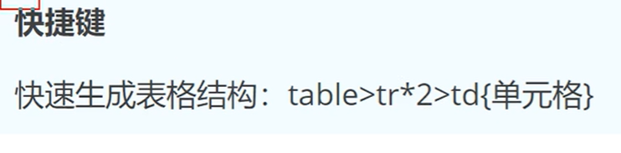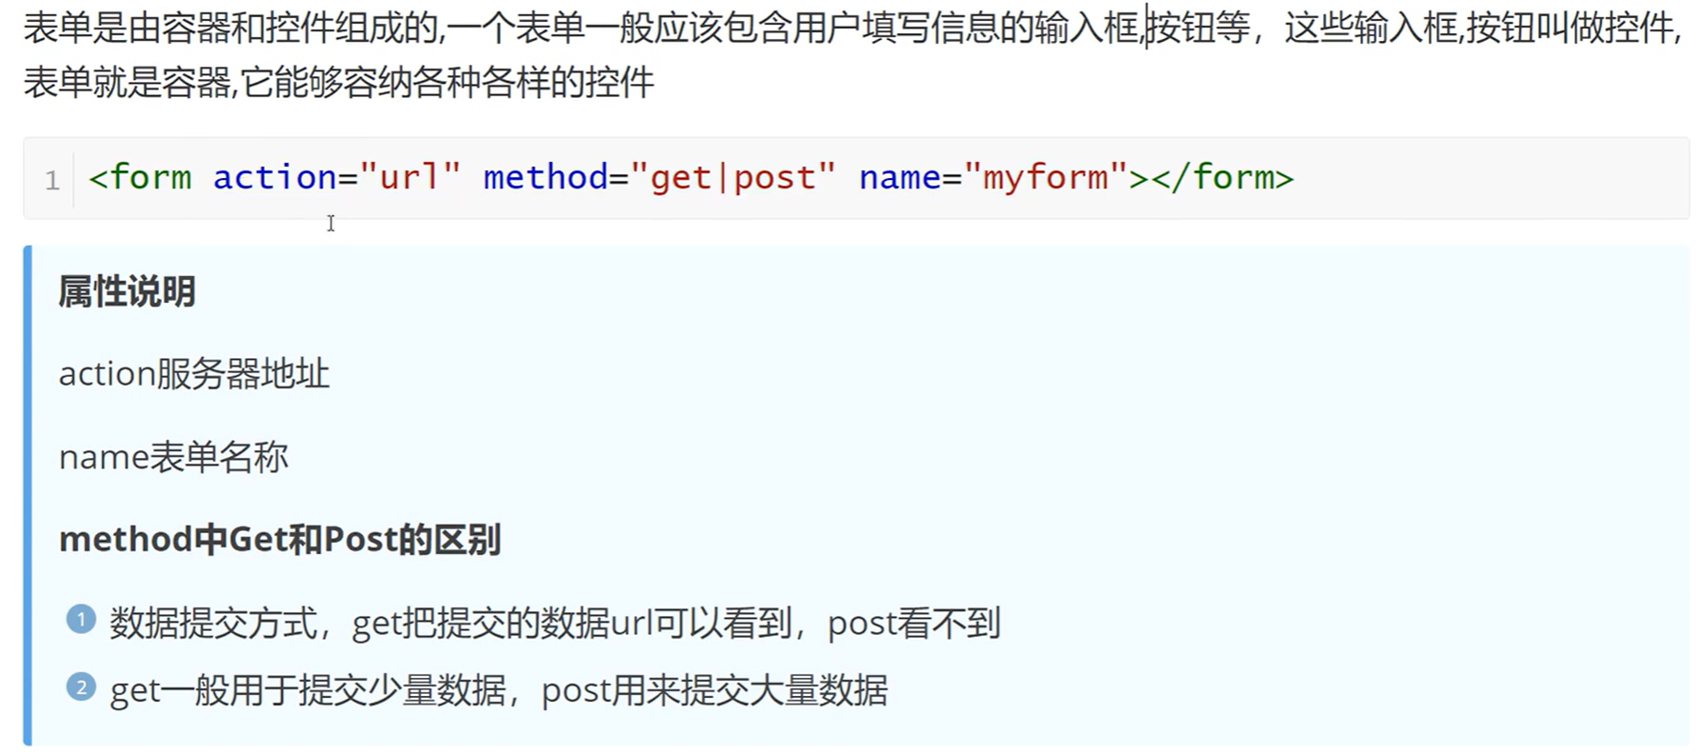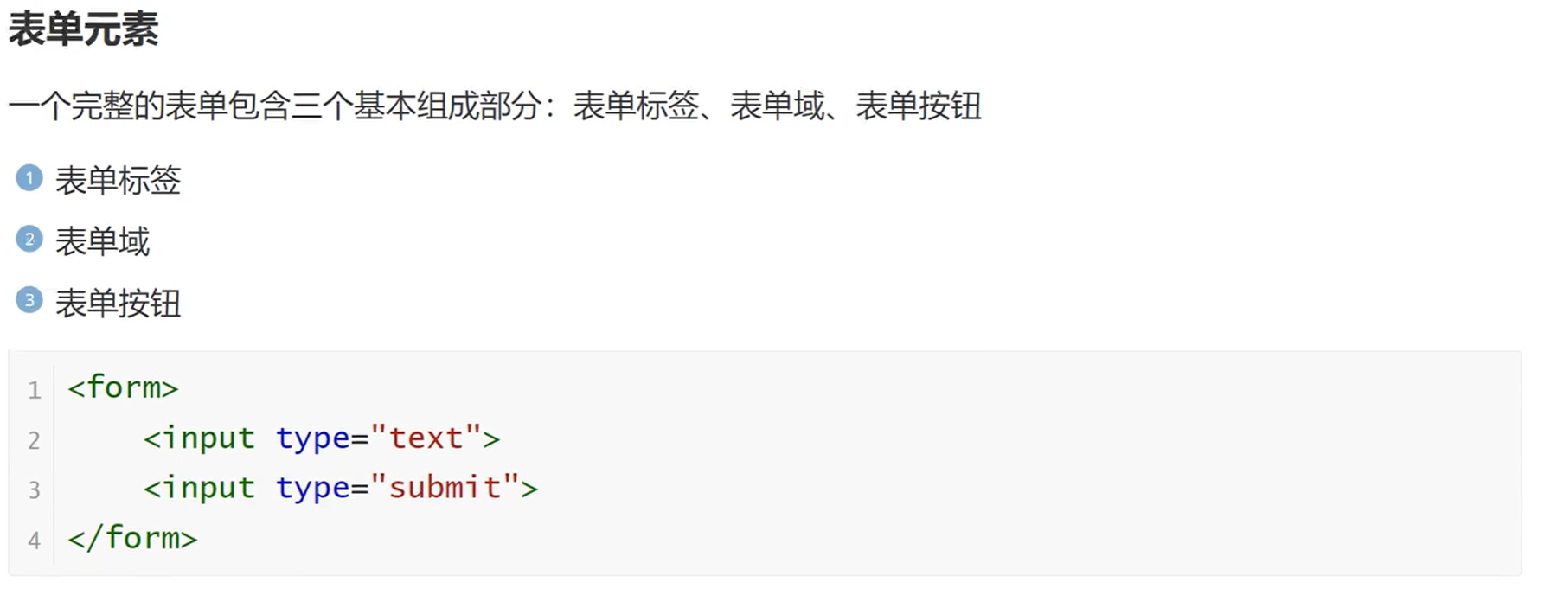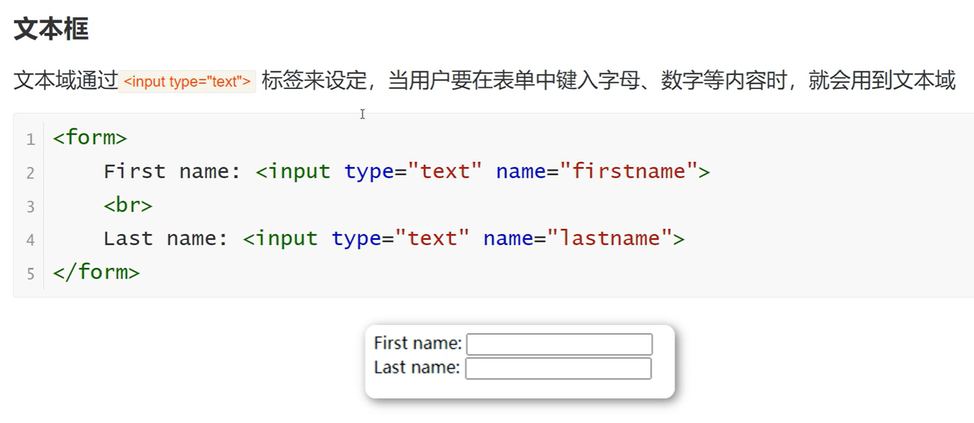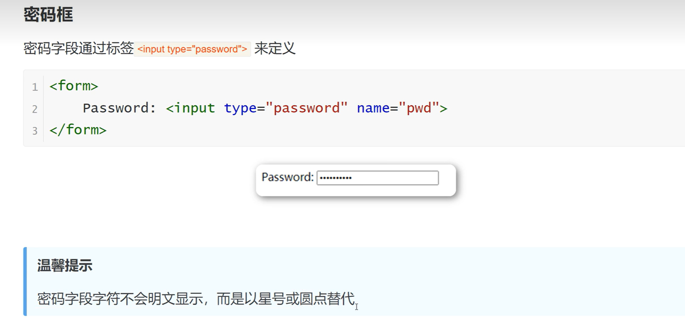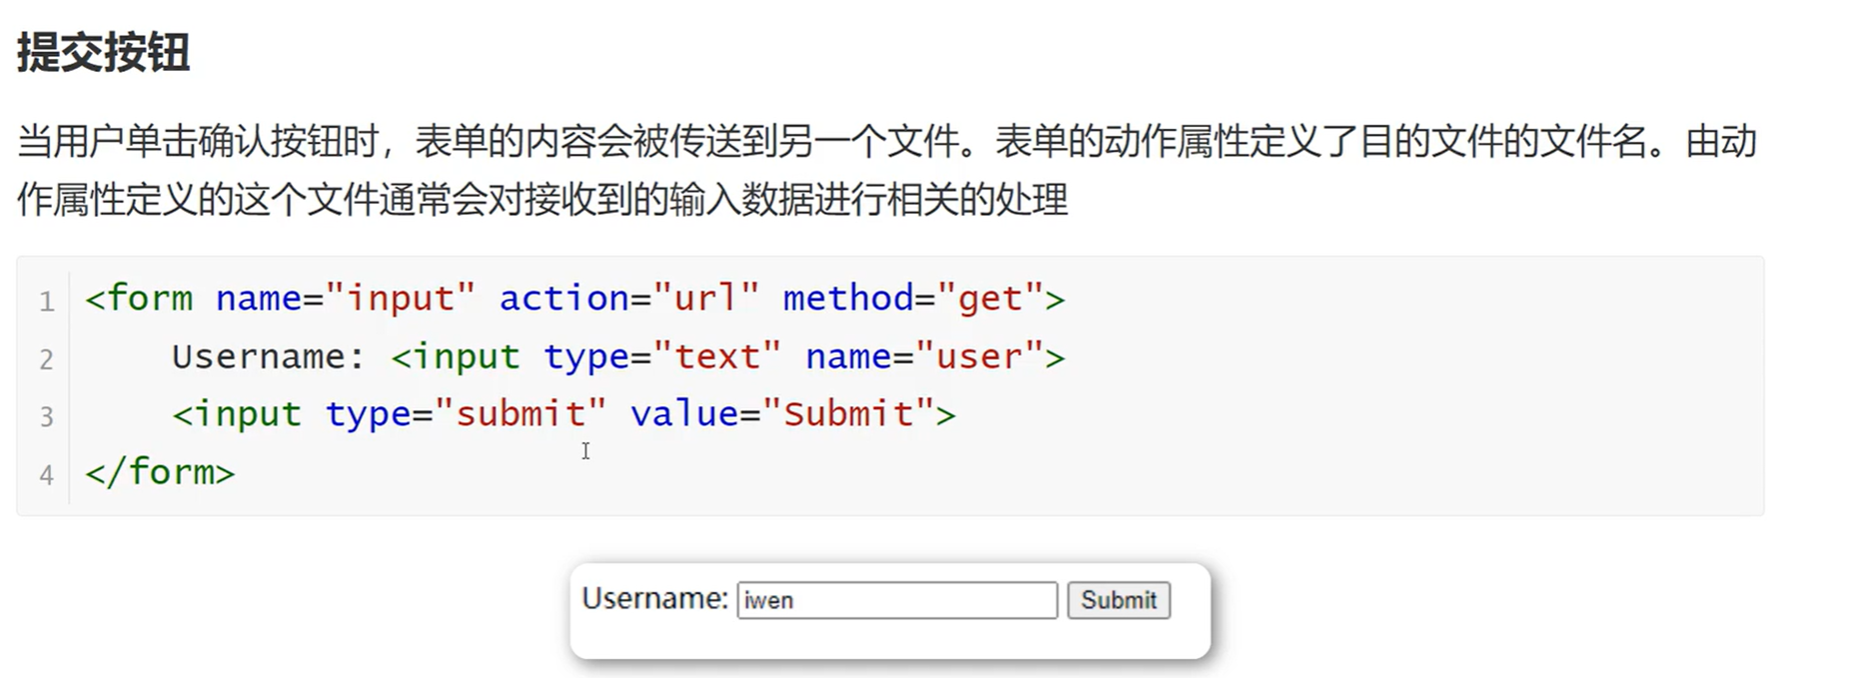

可在value=””里面该成登录等文本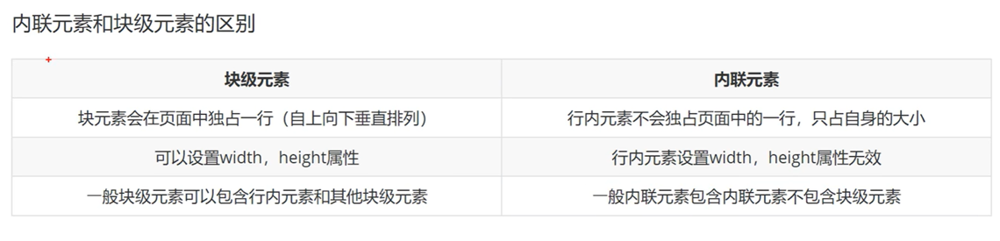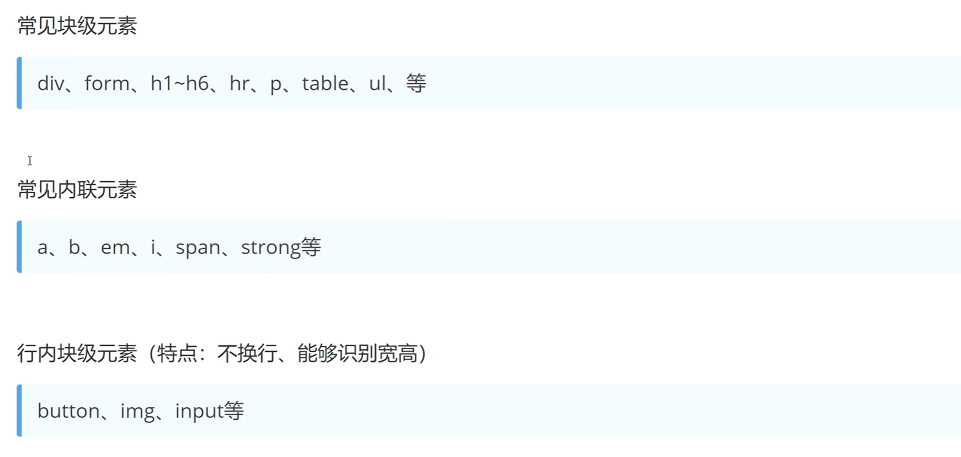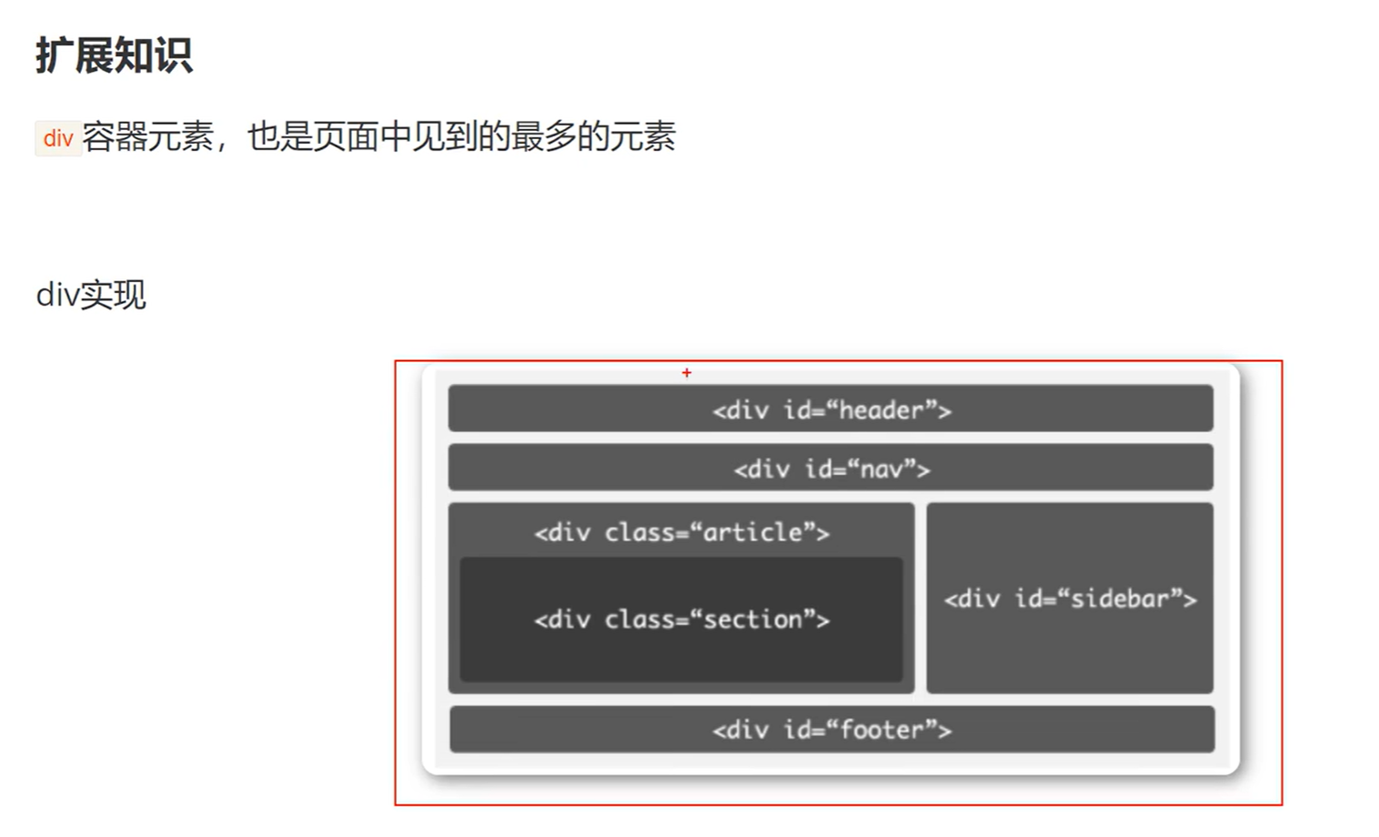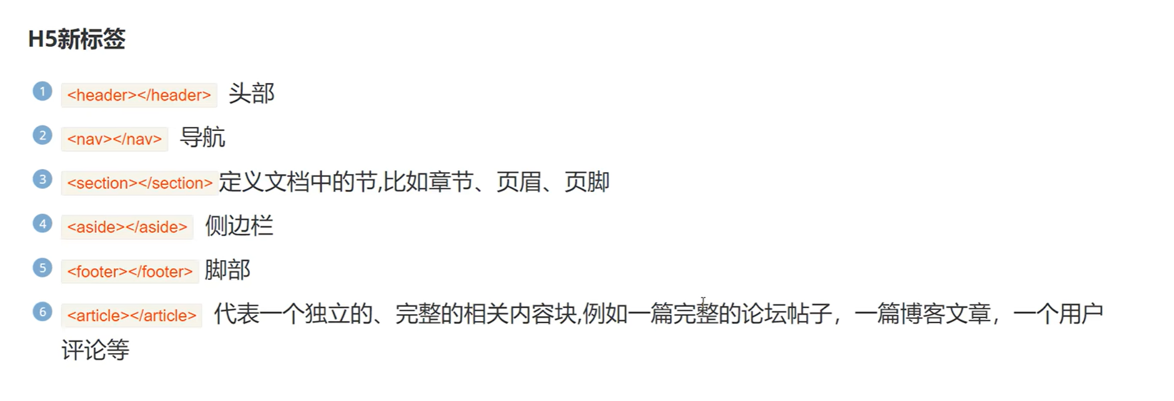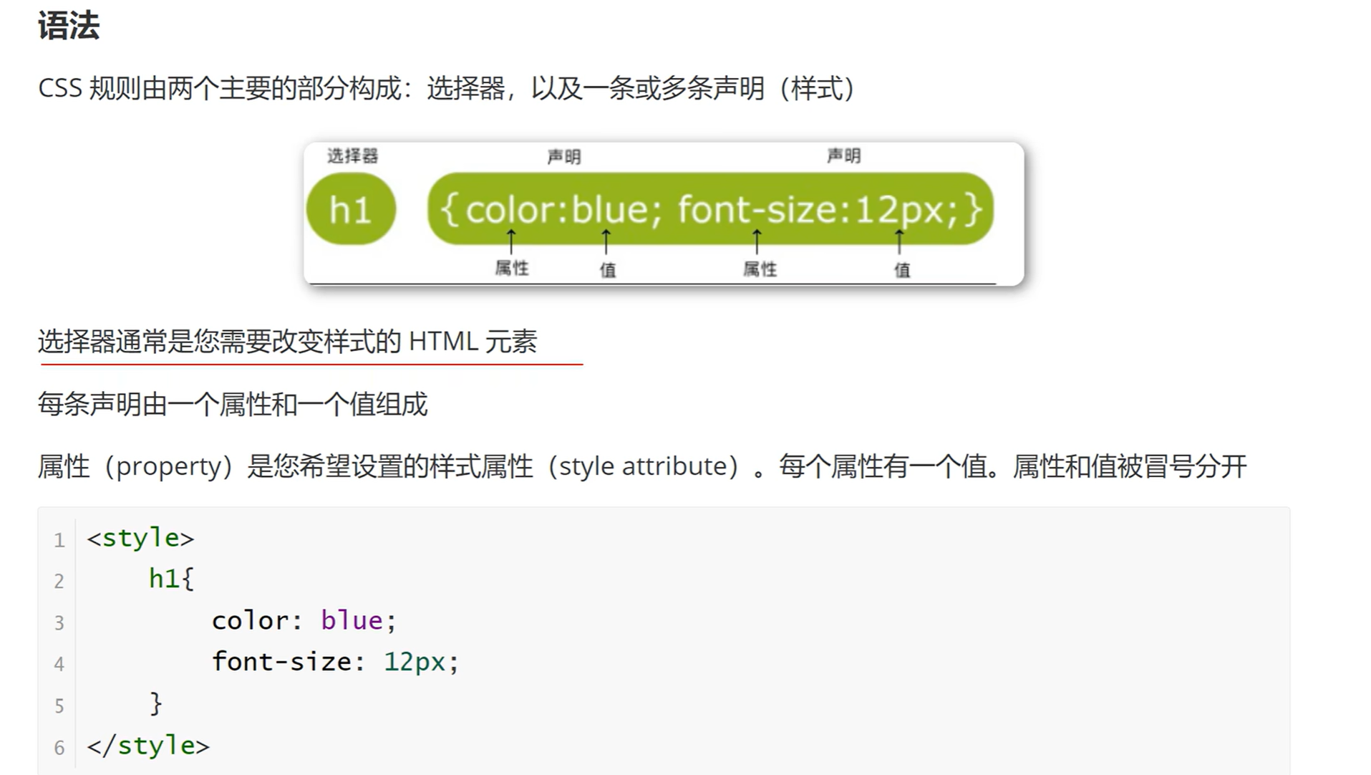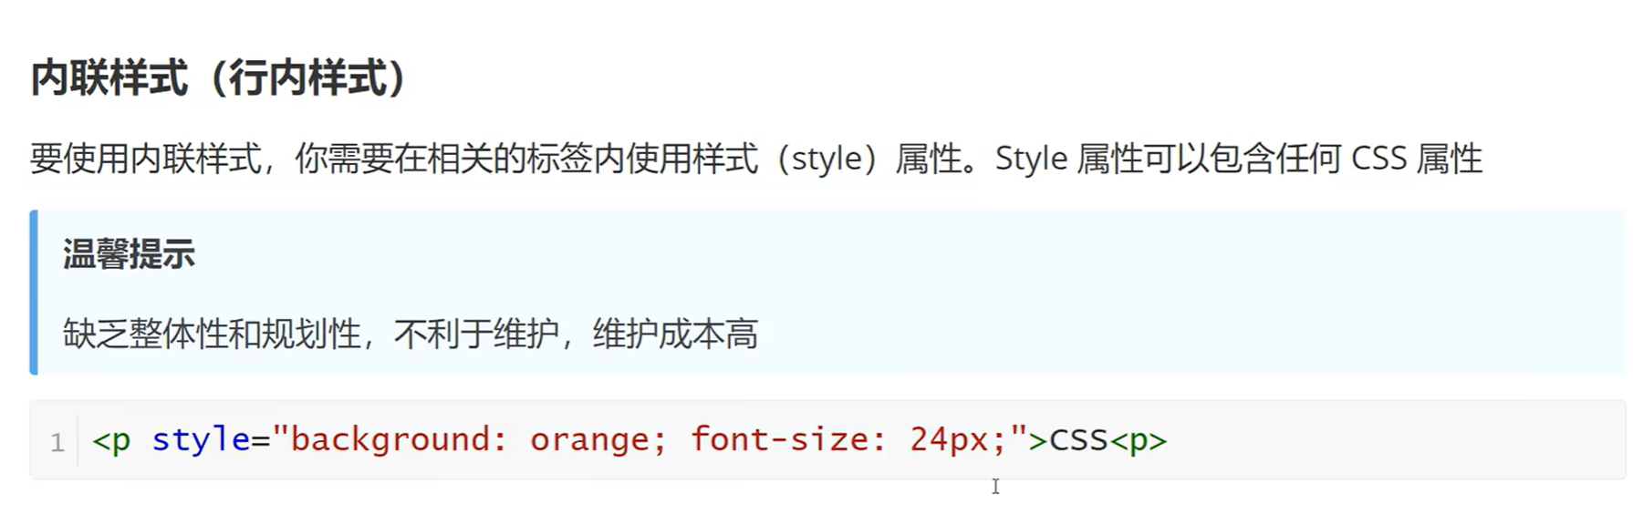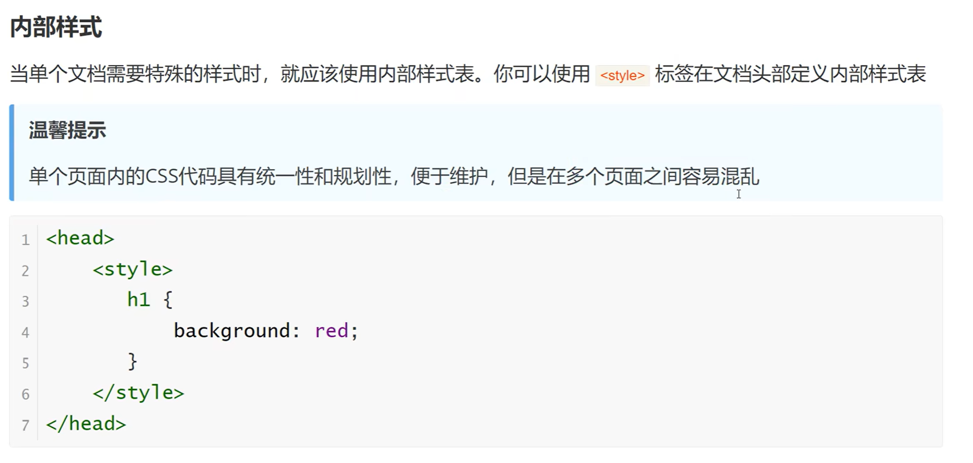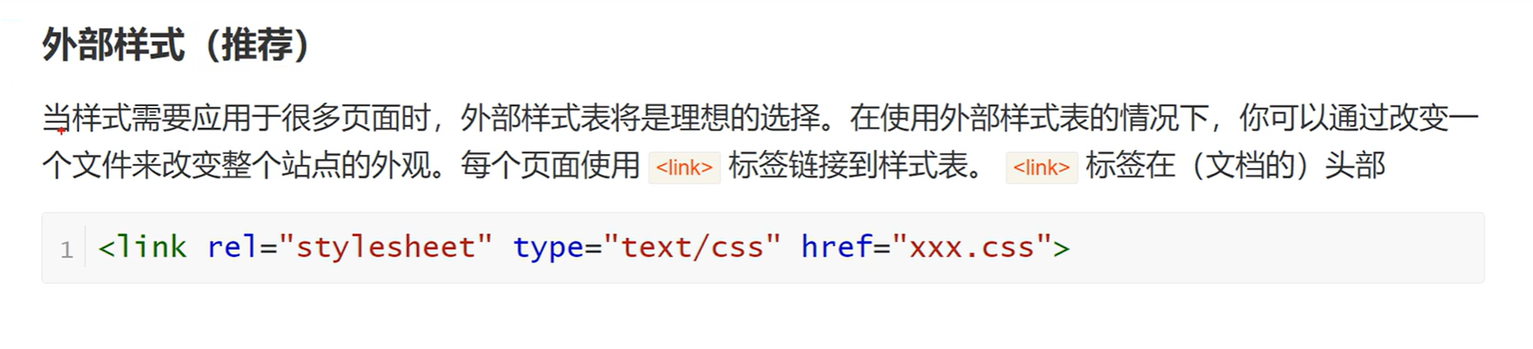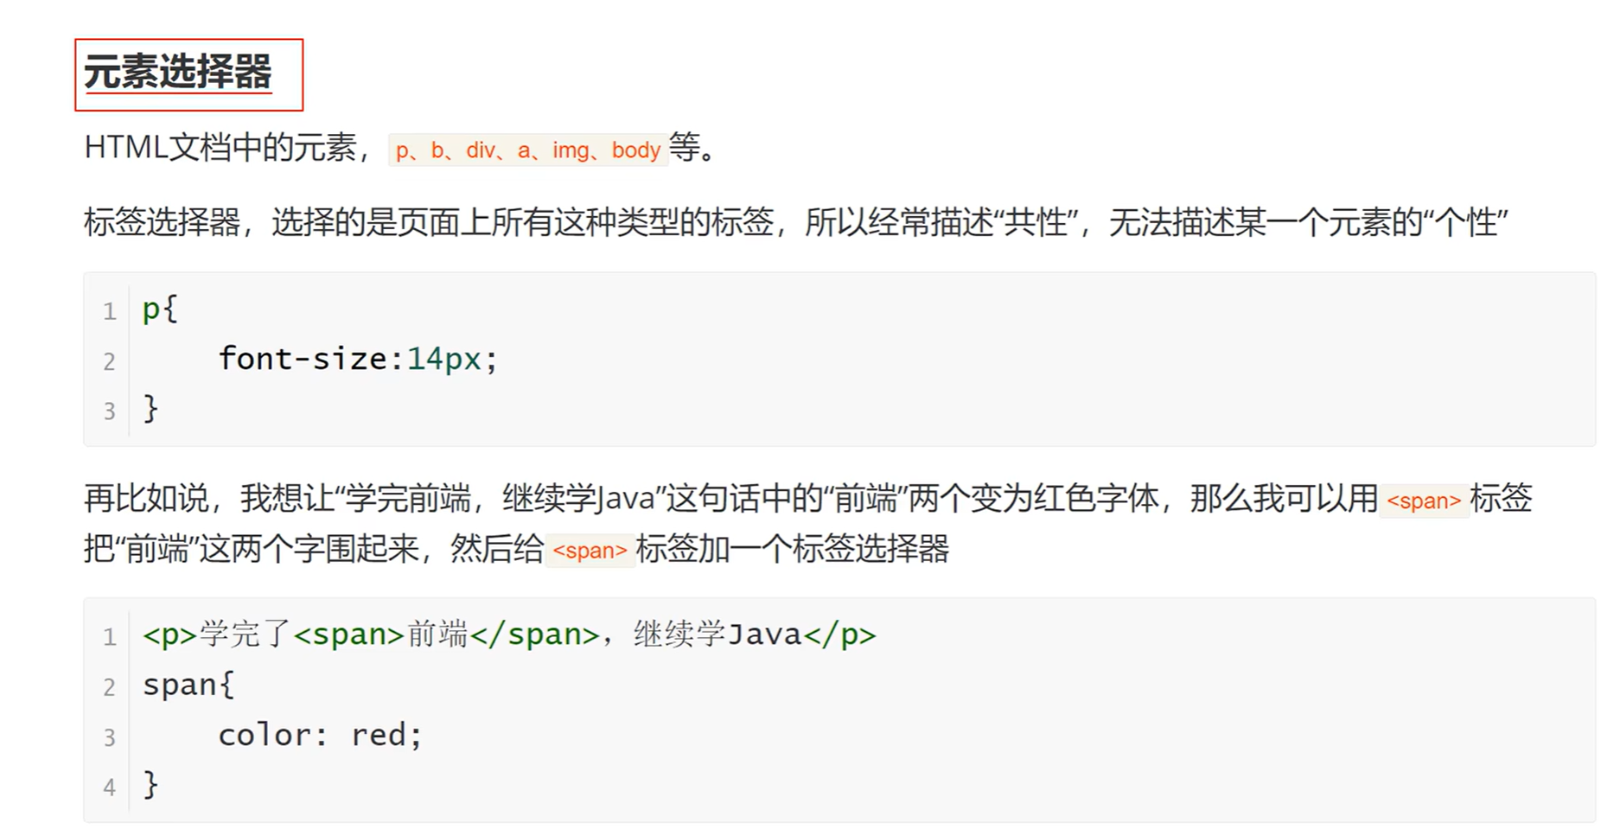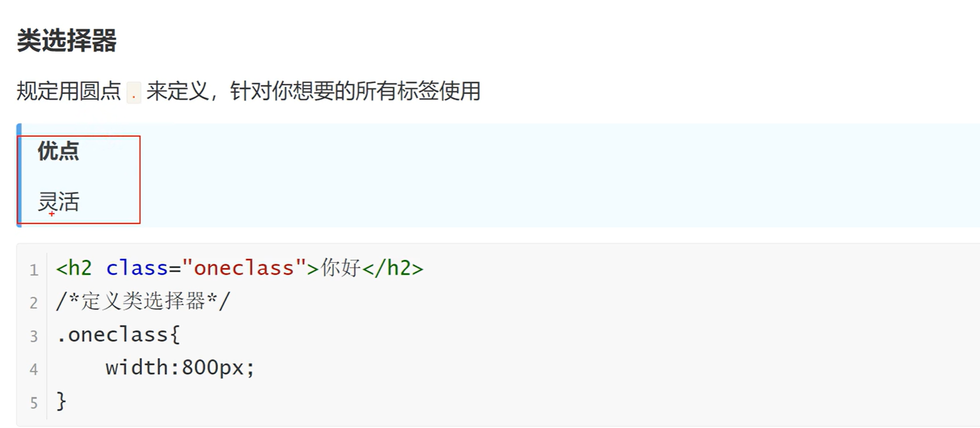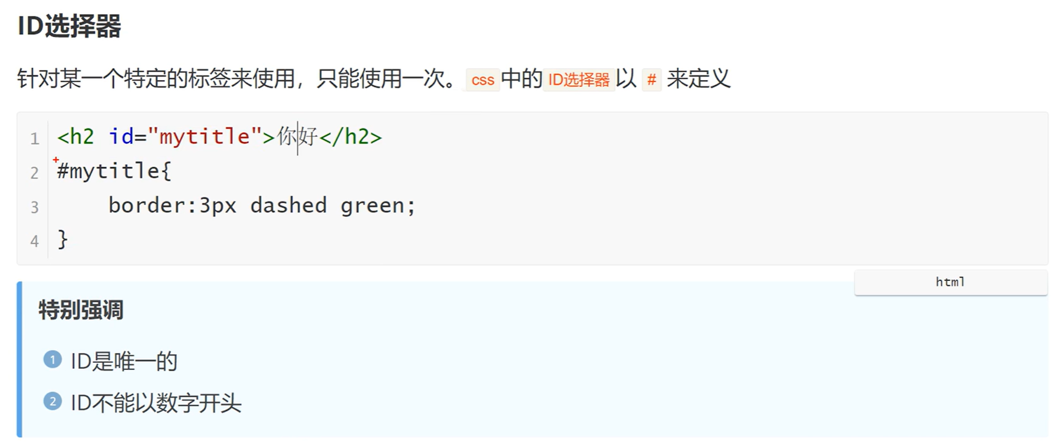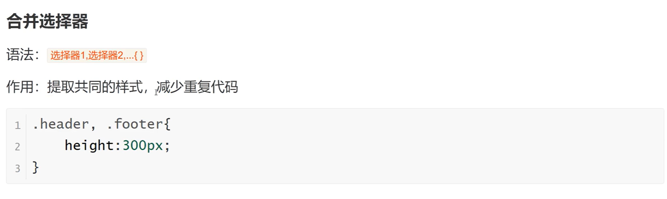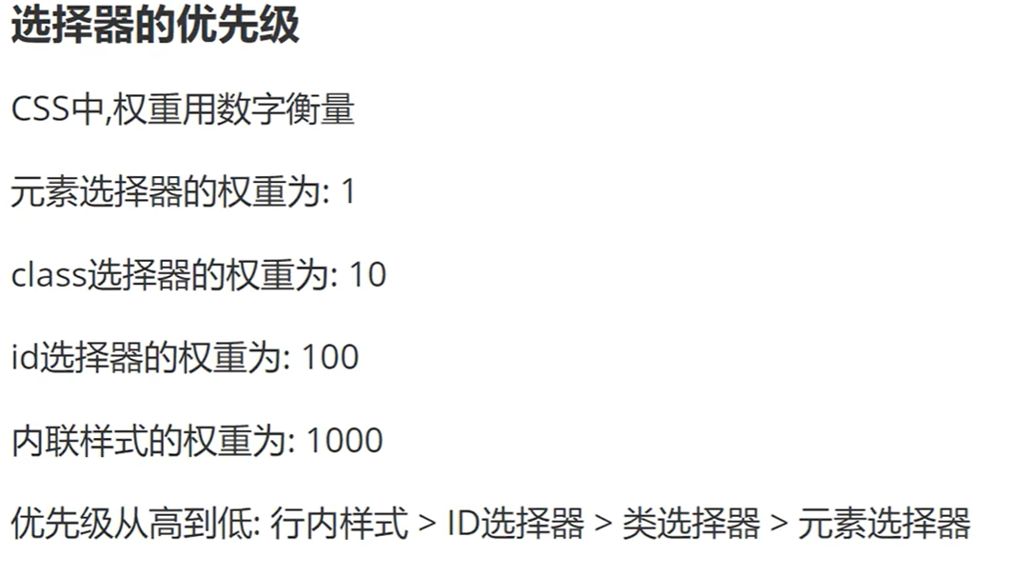

字体等设置看视频[023_字体属性_哔哩哔哩_bilibili](https://www.bilibili.com/video/BV1jj411P7Yp?p=24&vd_source=711b8e24c1755e85889642d9f0ab8b1e)

背景属性看视频[024_背景属性_哔哩哔哩_bilibili](https://www.bilibili.com/video/BV1jj411P7Yp?p=25&vd_source=711b8e24c1755e85889642d9f0ab8b1e)



文本属性看视频[025_文本属性_哔哩哔哩_bilibili](https://www.bilibili.com/video/BV1jj411P7Yp?p=26&vd_source=711b8e24c1755e85889642d9f0ab8b1e)

表格属性看视频[026_表格属性_哔哩哔哩_bilibili](https://www.bilibili.com/video/BV1jj411P7Yp?p=27&vd_source=711b8e24c1755e85889642d9f0ab8b1e)

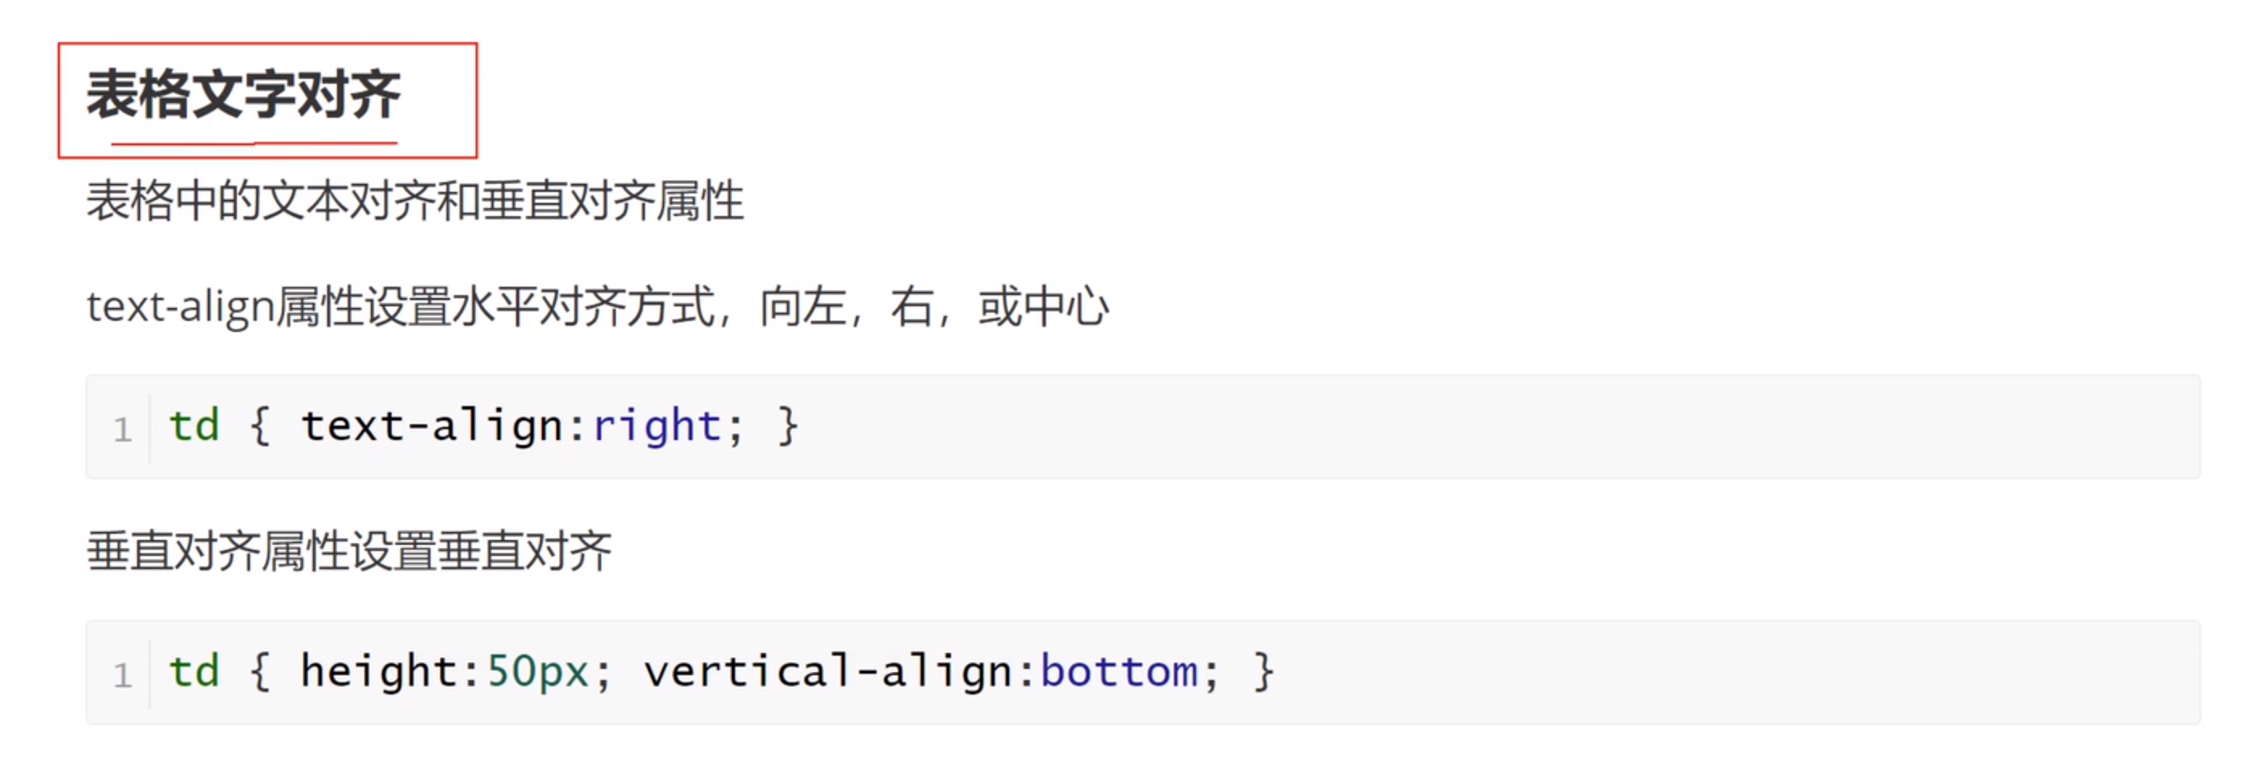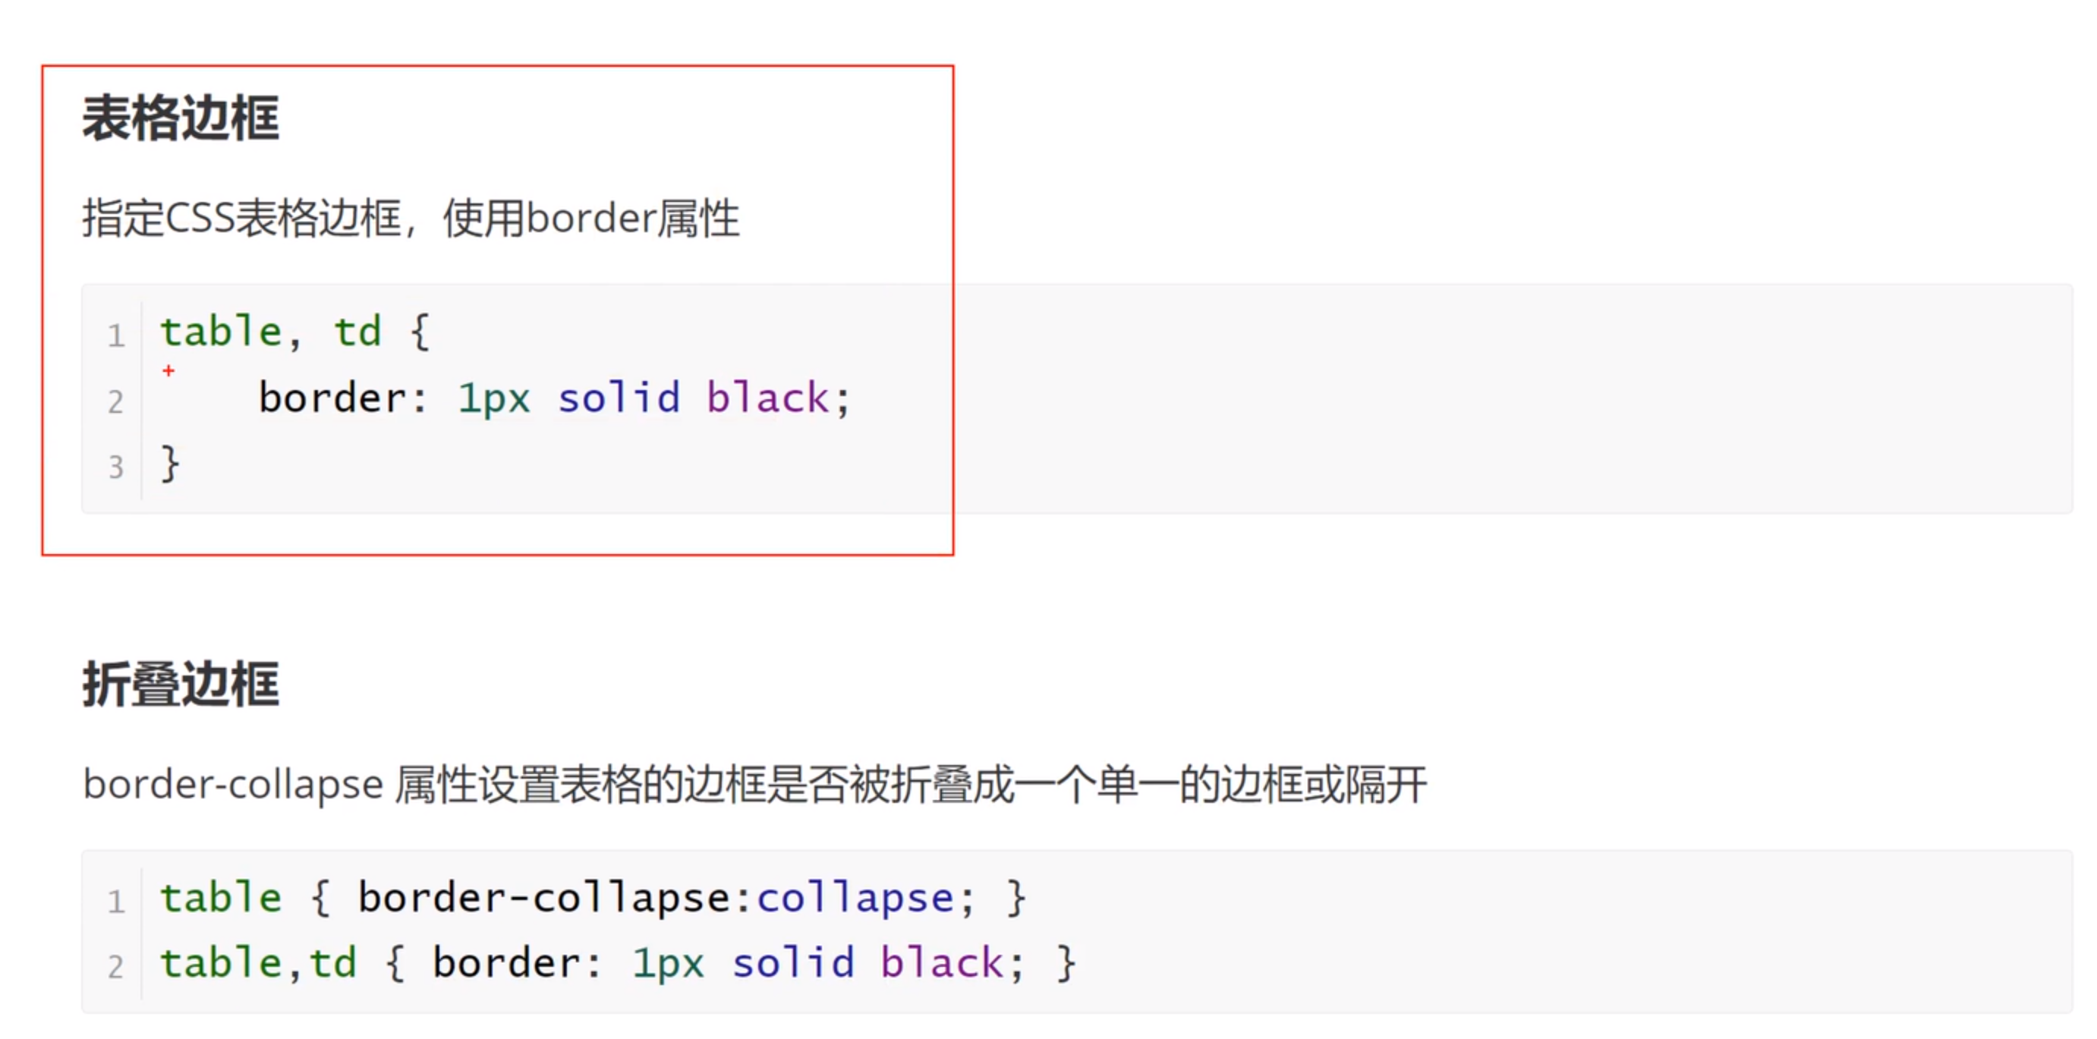

盒子属性[028_CSS盒子模型_哔哩哔哩_bilibili](https://www.bilibili.com/video/BV1jj411P7Yp?p=29&spm_id_from=pageDriver&vd_source=711b8e24c1755e85889642d9f0ab8b1e)